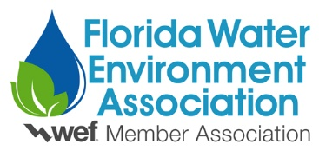
2020 FWEA Public Education Awards
The FWEA Public Education Awards recognize FWEA members for significant accomplishments in promoting awareness and understanding of water environment issues among the general public, through the development of and implementation of public education programs.
Categories:
- Individual
- Organization
- Events and/or Campaigns
Criteria:
The criteria are the same for each category.
- Documented achievements of water environment public education programs and activities.
- Identification and description of exceptional efforts to educate the public on water environment issues.
- A detailed narrative description of activities or efforts, including the objective and results.
- Member of the Florida Water Environment Association.
Submit:
• FWEA Public Education Award Application
• Biography for the Individual Category nominee
• Specific reasons for nomination (one page maximum)
• Copies of supporting documents in PDF form

All of the above documents must be uploaded as one PDF to the FWEA Awards page:
https://mms.fwea.org/members/form_edit.php?org_id=FWEA&fid=3225759

The use of videotapes and/or audio tapes will not be accepted.
Nominations Accepted From:
FWEA members
FWEA chapters
FWEA committees

Nominations Deadline: January 31, 2020

