STUDENT DESIGN COMPETITION
2020-2021 GUIDELINES
FLORIDA WATER ENVIRONMENT ASSOCIATION

STUDENT DESIGN COMPETITION
2023-2024 GUIDELINES

This event, sponsored by the Florida Water Environment Association (FWEA), requires that student teams design and present a project of their choice that relates to the field of water/ wastewater engineering, water resources, or other environmental topics. Any questions regarding the program guidelines should be directed to the Students & Young Professionals (S&YP) Committee Chair:

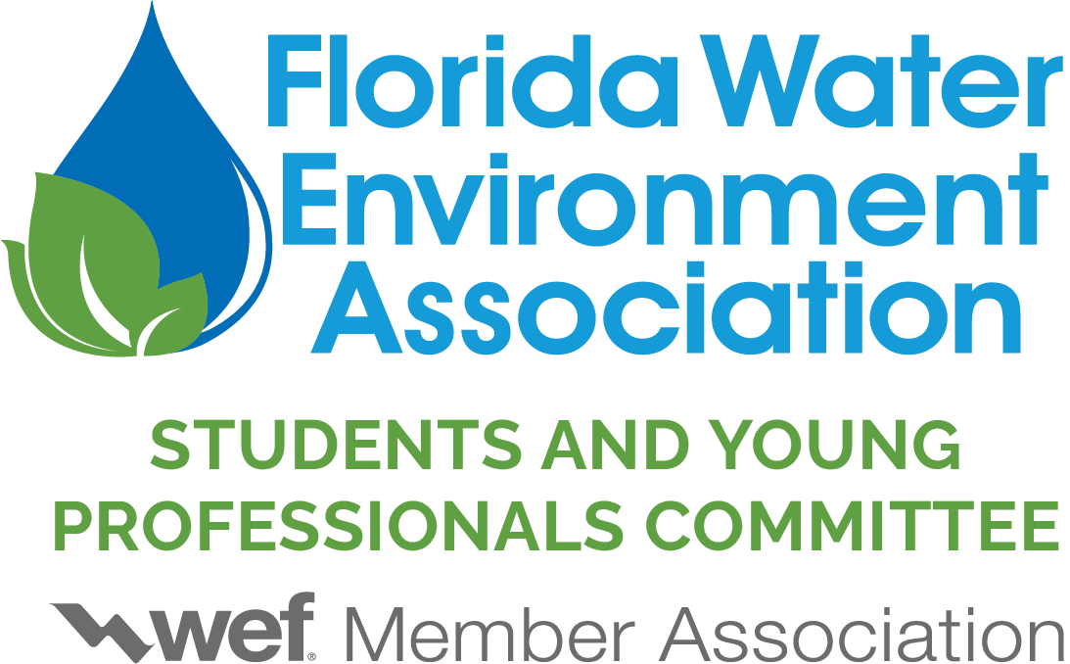

UNIVERSITY* | S&YP Student Design Competition Director
Florida A&M University  Florida Atlantic University  Florida Gulf Coast University  Florida Institute of Technology  Florida International University  Florida State University  University of Central Florida  University of Florida  University of Miami  University of North Florida  University of South Florida | Alyssa Massais  CDM Smith, Inc.  4651 Salisbury Road, Suite 420  Jacksonville, FL, 32256  Cell: 904-527-6729  Email: massaisaa@cdmsmith.com
*Others are welcome to participate

INTRODUCTION

The FWEA Student Design Competition (SDC) is intended to promote a “real world” design experience for students interested in pursuing an education and/or career in water resources and environmental engineering and sciences. This competition tasks teams of student members within FWEA to design and present a project solution meeting the requirements of a problem statement that they have worked on together as a team. This competition is intended for both undergraduate and graduate students, typically completing a capstone project.

STUDENT DESIGN COMPETITION

Student design teams will be able to compete in one of two categories: wastewater design (WW) or environmental design (ENV). The Wastewater design is intended to include the traditional wastewater collection and treatment design projects, e.g., hydraulic capacity design, upgrades to existing treatment systems, biosolids handling, small-scale community wastewater treatment designs, and other related topics. The Environmental design is intended to cover current contemporary engineering topics, including stormwater management, watershed management, green infrastructure, low impact development, water reuse, wetland construction, distributed treatment systems, groundwater treatment, drinking water treatment systems, and other related topics. The students will indicate on the Entry Form the category in which they will participate (WW or ENV). Final determination of project category is at the discretion of the FWEA Students and Young Professionals (S&YP) Chair. The competition consists of two portions, the written submittal and the presentation.

The scope and extent of the project should be at the level of a junior, senior, or graduate engineering/science student in a design or capstone course. Students may participate in the competition if they are not enrolled in a capstone course. Students are expected to work together as a team to recommend a solution, with little assistance from an advisor and/or professor. Students may use whatever references or resources, with appropriate citations.

Students are expected to perform the necessary calculations for the project. This is not intended to be solely a research project or a literature review, but a comprehensive design project. Although some initial literature review and/or research will be required, the bulk of the project should incorporate pertinent calculations for the design.

For example, if the project involved a wastewater treatment plant expansion, judges would expect that the team performed the following:

- Sufficient background information with a clearly stated problem statement
- Analysis of alternative solutions which may include a decision matrix
- Hydraulic profile
- Preliminary sizing of major equipment (aeration basins, clarifiers, chlorine contact chambers, etc.)
- Incorporated information from different manufacturers
- Population analysis to determine design flow rates
- Preliminary cost evaluation for both capital and operational costs.

All of the design work should be submitted in the design report, clearly labeled and referenced.
Teams will be evaluated by a panel of judges selected from the FWEA community and will be scored based on written and oral presentation skills. The written and presentation skills will be evaluated separately and added together for a total score (see Exhibit A for the sample judges scoring sheets). The presentations will be held at the Florida Water Resources Conference (FWRC) (www.fwrc.org).
Written data (submitted in electronic format) will be evaluated by the judges prior to the oral presentations. The data will be available to the judges during the presentation for their reference. After the presentation, judges are permitted to ask questions based on information provided in both the written submittal and the presentation.
ENTRY FORM
Each team shall submit an entry form for the competition. Each university is permitted to send up to two teams to the competition, one in each category (WW and ENV). The team names shall be referred to in the following manner: "University-Category." For example, UCF-WW or FGCU-ENV.
Each team will be required to submit an abstract on Page 2 of the entry form (maximum of 250 words). The purpose of this abstract is to help the S&YP committee verify that the project is entered in the appropriate category and that the project follows these SDC Guidelines. While the abstract included in the entry form will not contribute to the overall score of the project, it is important to be as descriptive as possible so that the project category can be verified.
There is no entry fee for the SDC. Students and other audience members are responsible for their own travel arrangements to attend the SDC. If interested in attending other portions of the conference, registration information may be found at www.fwrc.org. Each team must also submit the Participation Form at a later date that includes the names of team members and presenters.
PRIZES
FWEA is providing prizes for the 2024 program. The prizes shown below, which are subject to change each year, will be awarded following the Student Design Competition at FWRC. Please note that each team participating in the event will receive a participation bonus for their team regardless of placement based upon the presentations and written submittals. Students will indicate on the Entry Form where the check should be sent.

PRIZE | AWARD | MONETARY VALUE
First Place  (Wastewater Design) | Norm Casey Scholarship  WEFTEC 24 Travel Allowance* | $1,000  $4,000
First Place  (Environmental Design) | Norm Casey Scholarship  WEFTEC 24 Travel Allowance* | $1,000  $4,000
All other teams | Participation Bonus | $500
*The first-place teams will be required to present their projects at the Water Environment Federation (WEF) Student Design Competition, to be held at WEFTEC 24 in New Orleans, Louisiana October 5 - 9, 2024. The winning teams from each category (Wastewater and Environmental) should follow the WEF deadlines and guidelines for the national competition, located on their website. Note that some items may be due as early as May.
The first-place winners in each category will be announced at the conclusion of the SDC.
GENERAL REQUIREMENTS
The general requirements for participation in the competition are:
- Team size will be limited to a maximum of eight students per team. One team per school is allowed in each design category. It is recommended that schools with more than one team interested in a design category host an internal competition to determine the team who will compete at the FWEA Student Design Competition. A school may send a maximum of two teams, one in each design category.
- The sponsoring professor should provide limited assistance to the students on an as needed basis, keeping in mind that this project should be the students’ opportunity to showcase their knowledge gained throughout their time in school.
- The engagement of the professional community and the local chapters of the FWEA is strongly encouraged. Project topics, design data, and feedback may be obtained from members of the professional community.
- Attendance at the Student Design Competition at FWRC.
- Each member of each team must be a WEF/FWEA Student Member in good standing who:
  - Have been selected by their university to participate.
  - Have filed an application with their FWEA student chapter and paid the required dues prior to March 29, 2024. The same holds true for continuing Student Members.
  - Student members who have graduated at the time of the FWEA Competition will be allowed to participate if they were a registered student within the last 6 months. Students who have graduated must also be a member of WEF/FWEA.
- All entry materials become the property of the FWEA.
- A representative of FWEA will preside during the competition and ensure that there is adherence to the time schedule and event rules.
- The first-place team in each category should be prepared to participate in the National Student Design Competition at WEFTEC 24 New Orleans, Louisiana October 5 - 9, 2024. Some travel funds are provided as part of the first-place award.
STUDENT RESUMES
Students may submit resumes at the same time as the written data submittal. Student resumes will be reviewed by industry professionals prior to the competition. Students will receive a copy of their resume with constructive feedback after the competition. After the SDC, a brief career panel/resume workshop will be held, where students will have the opportunity to speak directly with industry professionals and receive additional feedback. Students should also bring hard copies of their resumes with them to the competition/resume workshop.
After students receive feedback, we ask that they submit a revised resume within one week of the competition, which will be distributed to all Gold-level sponsors. Resume deadlines are listed under the Significant Submittal Items and Dates Section.
Guidelines for student resumes include:
- Each student is limited to one page.
- The resumes for each team shall be combined and submitted as a single pdf document with the following file name format: "School_Category_Resumes" (example: "FIU_WW_Resumes”, “FGCU_ENV_Resumes").
- The resumes are to be separate from the written submittal (report).
- Late resumes will not be accepted.
- Submitting a resume is not mandatory, however it is strongly encouraged. Teams will not be penalized for not submitting resumes.
WRITTEN SUBMITTAL REQUIREMENTS
Design documents shall be compiled in Adobe Acrobat (pdf). Competition entries shall be submitted by email. Special indices, bookmarks, or other features are appreciated, but not required.
The following shall be included in the written submittal (in the order shown):
- Abstract/Executive Summary – Provide a brief overview/ summary of the design, not to exceed 250 words. This section is not counted as part of the 20-page limit.
- Team Member Roles – Provide a summary of each team member’s role in the effort. This section is not counted as part of the 20-page limit.
- Report – A discussion of the design problem statement, approach, and solution (not to exceed 20-pages*). The discussion must cover the salient facts upon which the recommendation is made, give a clear analysis of the evaluation technique, and present a clear recommendation of action. Relevant data should be presented in the discussion in a clear and logical format. All elements shown on the judging score sheet should be addressed.
  - Formatting: 1-inch margins on all sides; Calibri, Arial, or Times New Roman Font with a minimum 11-point font size. Reports may be single or double-spaced.
  - Color diagrams, tables, graphs, charts and photographs that reflect the unique features of the project. Each graphic/photo is to be identified with an appropriate descriptive caption and may be embedded in the report or included at the end in appendices. It is recommended that smaller, pertinent graphics be embedded in the body of the report while large and supportive graphics be included in the Appendix. It is not recommended to have all graphics only in the Appendix.
  - References: Any information not original to the design team (including text and graphics) must be appropriately referenced. Carefully review each section of the written submittal to ensure references are cited appropriately, including in-text citations.*
*Noncompliance may result in scoring penalties (see Penalties section).
- References/Acknowledgements – Give credit to your sources of information and outside support. This portion does not count as part of the 20-page limit.
- Supporting Documentation – Provide drawings, calculations, tables, vendor submittals, cost estimates, and other voluminous documents as appendices. There is no limit on the number or length of appendices to include at the end of the report. This portion does not count as part of the 20-page limit.
The judges will be directed to focus their review on the Report section of the submittal. Teams shall ensure that their complete analysis and design solution may be understood from the 20 pages of material provided in the Report.
Teams are encouraged to use a checklist to ensure all necessary documents are included in the written submittal. Failure to include all documents may result in a lower score.

PRESENTATION REQUIREMENTS
Each team will be allowed a thirty (30) minute block of presentation time, including a two (2) minute setup, fifteen (15) minute presentation directly followed by a thirteen (13) minute question and answer session. There will be time warning signs held up during the presentation when there are 5 minutes and 1 minute remaining to help the students from going over their time allotment. To stay on schedule, the presentation will be kindly cut off after 15 minutes, even if there are slides remaining. Therefore, time management and practice are important. There will be two rooms for the presentations, one for the Wastewater Category, and one for the Environmental Category. Typically, both SDCs will occur simultaneously.
This year, teams are asked to bring handouts of their presentation slides for the judges. These should be front and back with three slides per page with the notes sections. Please provide six (6) copies of the handouts. The judges will use these during the presentations so last-minute changes should be limited.
Teams may consist of up to eight members. However, a maximum of four team members shall be permitted to present and answer questions. If there are four or less team members on the presentation platform, each member is expected to have a role in the presentation and in answering questions. If required, one additional team member (a fifth team member) may be on the presentation platform but shall be dedicated solely to advancing the presentation slides. Additional team members are not permitted on the presentation platform or allowed to speak during the presentation or the question-and-answer period. However, they are encouraged to show their support as audience members. All presenting team members (excluding the A/V member) are encouraged to participate in the question-and-answer session. Questions are drawn from the judging panel only. The presentation rooms will have a standard podium, screen, laptop, and projector. The laptop supports PowerPoint 2007 or better.
SIGNIFICANT SUBMITTAL ITEMS AND DATES
Each entry will consist of the following:
- An official Entry Form submitted to the S&YP SDC Director by 11:59 pm on February 16, 2024. This submittal does not need to identify team members but must include contact information for each team planning a submittal. Please contact the S&YP SDC Director in advance if a university has multiple teams interested in one category and is intending to hold an internal competition after the Entry Form deadline.
- The entry form is to determine what category a team is placed in. If a team's topic changes after the entry form has been submitted, the team must contact the S&YP SDC Director immediately to ensure their new topic still fits within their category.
- A Conference Call will be held in March 2024. An exact date/time will be determined in early February. A conference call number and passcode will be sent out to each team leader (listed on the Entry Form). At least one team member from each team is required to call in. The purpose of the conference call is to review competition rules and to answer any questions the students may have. Please notify the S&YP SDC Director of any conflicts prior to the conference call.
- A Participation Form showing final team member names and presentation title, submitted to the S&YP SDC Director by 11:59 pm on March 22, 2024. The presentation title should be related to the project topic listed on the Entry Form.
- A project written data submittal must be received by the S&YP SDC Director no later than 11:59 pm on March 22, 2024.
- Preliminary student resumes must be received by the S&YP SDC Director no later than 11:59 pm on March 22, 2024.
- The presentations will be made on April 6, 2024 at the Florida Water Resources Conference. The S&YP SDC Director needs to receive the final presentation prior to the competition to check for technical difficulties prior to the start of the competition. Teams will need to verify that their presentation is on the general laptop before the competition. Students may bring their presentations on a portable flash drive to transfer it to the general laptop.
- Revised student resumes must be received by the S&YP SDC Director no later than 11:59 pm on Friday April 26, 2024.
JUDGES AND JUDGING CRITERIA

The event will be judged by an impartial panel consisting of members of academia, public agencies and private consulting practices. The judging team shall have no direct affiliation/representation with any college participating, owner project, or engineering firm involved as part of the projects they will be judging. All written submittals and presentations will be judged by the same panel of judges for each category, Wastewater and Environmental.
The FWEA is a multi-disciplined environmental organization dedicated to quality in practice of the profession. Accordingly, judging will be based on the elements outlined below and on the scoring sheets provided in Exhibit A. Judges will use the scoring sheets provided as the basis for judging of the students’ designs. The FWEA presiding official will hold the results of the written submittal scores until after the presentations are complete and scored. The scoring sheets will be collected after the presentation and the scores will be added to the written scores and tallied. The team with the highest score in each category will be awarded First Place. In the event of a numerical tie, the winner will be decided by the scoring of the presentations. If this ranking also results in a tie, a coin shall be flipped to determine the first-place finishers (and state representatives to WEFTEC 24). The final scores may not be released; however, comments and feedback from the judges will be compiled and provided to the students after the Student Design Competition.

WRITTEN SUBMITTAL
Technical
Were the instructions followed in the delivery of the written data? Does this submission substantially conform to the guidelines? Was there a clear final recommendation? Was it easy to follow the team’s approach in reaching their final recommendation?
Appearance and Structure
Is the written submittal clear, easy to read and navigate? Does it have a logical flow? Was the appearance of the data and presentation materials neat, organized, and professional? Is it free of grammatical and spelling errors? Did the report stay within the page limit? Was the report broken down into sub-headings that made it easy to follow?
PRESENTATION
Content
To what extent was the subject of interest conveyed to a technical audience? Did the team give credit for source of material or contribution? How much knowledge of the subject was exhibited? Was work independent and original? Was the subject technical or general in nature? Was the approach effective in solving the problem statement? Was the problem clearly stated? Did the students present a viable solution to the problem? Was there any innovation or “thinking outside the box” on the design approach? Were the design challenges addressed and overcome?
Organization
Were there an appropriate number of slides? Were the slides cluttered with too many details? Was there enough time for the audience to understand the information on each slide? Was there sufficient background information provided to introduce the audience to the subject? Were facts developed in logical and continuous sequence? Was there a definite conclusion and was it adequately based on the facts or data presented?
Delivery and Effectiveness
Were the words distinctly pronounced and did presenter use proper volume in delivery? Did the presenter use proper English, and was the vocabulary sufficient? Was personal appearance appropriate? Were there any distracting mannerisms? Was the manner of delivery (conversation, memorized, read from manuscript) satisfactory? If visual aids were used, how effectively were they used? Was the presentation within the time limit allowed for presentation? Were the speakers talking at an appropriate pace or were they rushed?
Discussion
Did the presentation evoke spontaneous questions from the panel? Did questions indicate the need for clarification of facts presented or were they merely of the type seeking additional information? How readily and with what self-assurance did the speaker answer questions? Did the answers indicate knowledge of the subject beyond that disclosed in the original presentation?
PENALTIES
Penalties may be assessed for misconduct by any of the teams and are at the discretion of the S&YP Committee.
Penalties may include:
- Points taken off from the final score
- Disqualification of an individual team
- Disqualification of a school
Some of the items that can lead to penalties include:
- Failure to submit entries on time
- Failure to comply with abstract or report guidelines
- Failure to comply with presentation guidelines
- Inappropriate assistance from a mentor, professor or other outside source
- Plagiarism, all sources and resources must be properly cited
- Failure to obtain WEF/FWEA memberships
- Misconduct by the team, sponsors or others associated with the team
SPONSORSHIPS
In addition to FWEA funding, the SDC is largely supported by the generous financial contributions of sponsors. If you know of an organization who is interested in sponsoring the SDC, please have them contact the S&YP Chair below. All sponsors will receive recognition for their support and their logo will appear on all SDC materials and the FWEA S&YP webpage.
INTERNET LINKS
http://www.fwea.org/student_design_competition.php
www.fwea.org
www.fwrc.org

QUESTIONS OR COMMENTS
Please review the entire SDC Guidelines and contact the S&YP SDC Director for any clarification on any of the rules or guidelines of the program. The Director may be contacted at:

Alyssa Massais
CDM Smith, Inc.
4651 Salisbury Road, Suite 420
Jacksonville, FL, 32256
Cell: 904-527-6729
Email: massaisaa@cdmsmith.com

For any other SYPC questions, you can reach out to the SYPC Chair:

Nicole Cohen
Carollo Engineers, Inc.
Cell: 239-357-5374
Email: ncohen@carollo.com

Good luck and thank you for your interest and support!

EXHIBIT A

SAMPLE JUDGES’ SCORING SHEETS

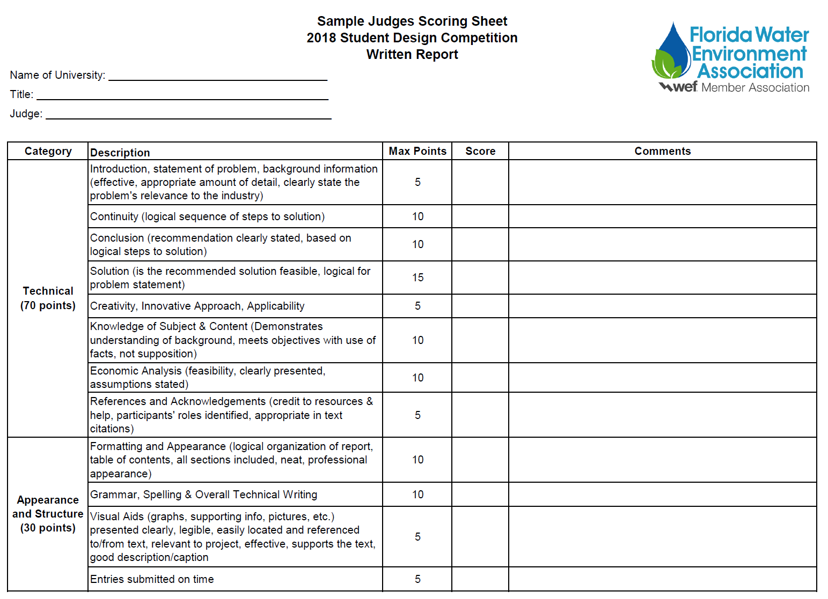
2024
2023
2020
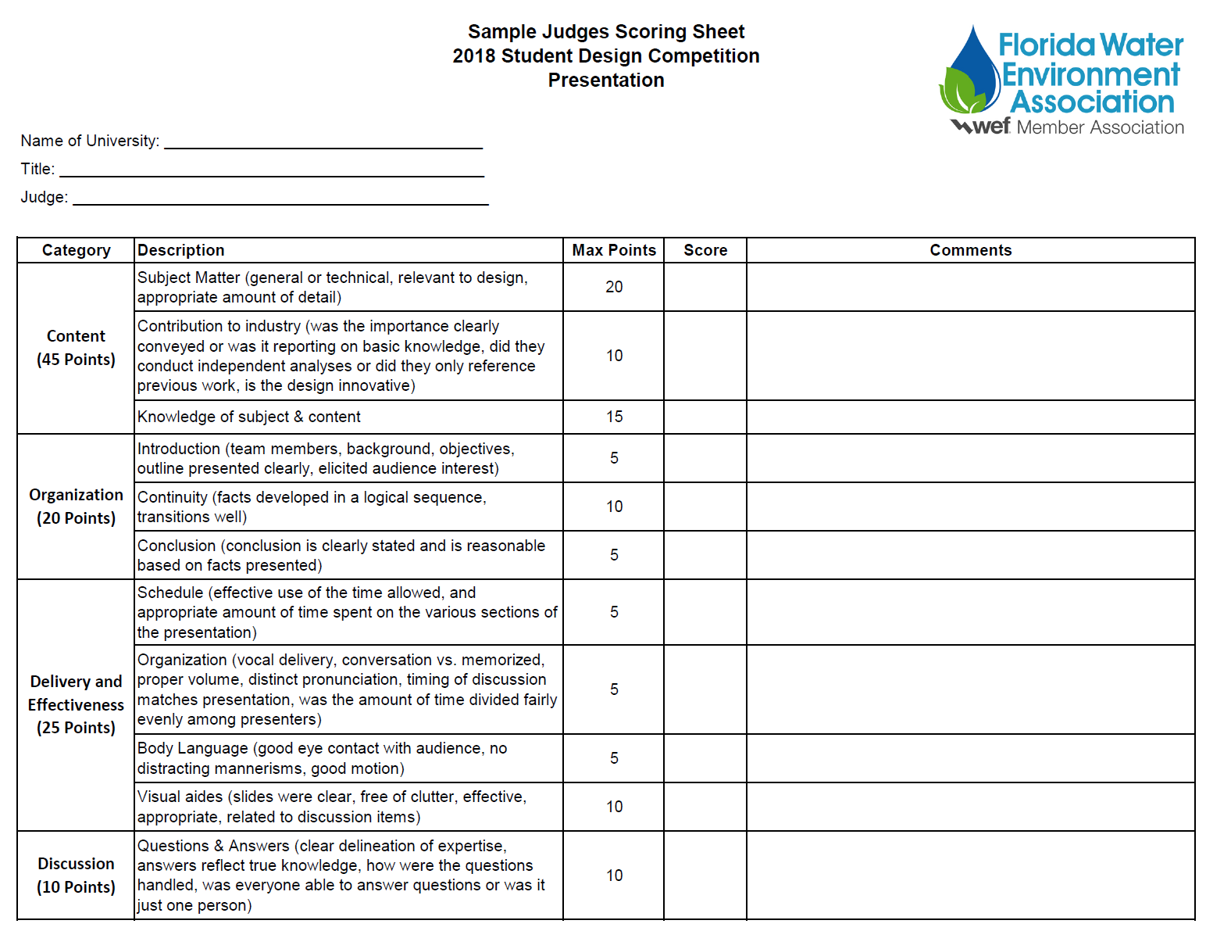
2024
2023
2020

