FWEA and FSAWWA

STUDENTS AND YOUNG PROFESSIONALS POSTER COMPETITION
2024 GUIDELINES

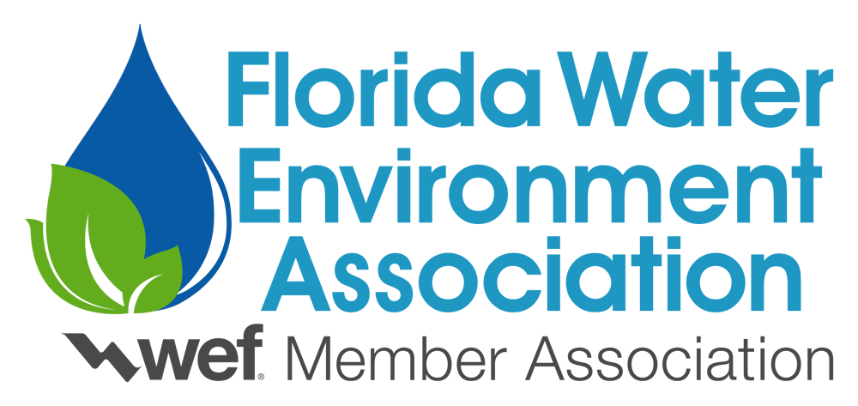

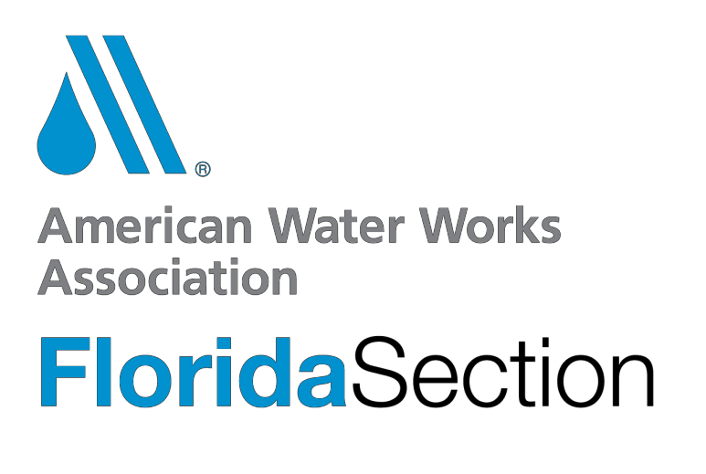

FWEA and FSAWWA
STUDENTS AND YOUNG PROFESSIONALS POSTER COMPETITION 2024 GUIDELINES

This event, sponsored by the Florida Water Environment Association (FWEA) and Florida Section of American Water Works Association (FSAWWA), requires students and young professionals to present a project of their choice that relates to the field of wastewater engineering, water resources, or other environmental topics. Any questions regarding the program guidelines should be directed to the Students & Young Professionals Committee (S&YPC) Poster Competition Chair:

Alyssa Massais
CDM Smith, Inc.
Work: 904-527-6729
Email: massaisaa@cdmsmith.com
Poster Competition Chair

INTRODUCTION

The Students and Young Professionals Poster Competition is intended to provide students and young professionals the opportunity to participate at the Florida Water Resources Conference. The posters will be judged by a panel of experts on Thursday, April 4, 2024 (afternoon). Participants may arrange their posters anytime between 8 am and 12 pm on Thursday. Posters must be on display prior to 12 pm on Thursday, April 4, 2024 in order to be considered. Authors must be present during the judging time (to be announced) in case judges have questions. Posters may remain on display throughout the duration of the conference. Authors are responsible for removing their poster prior to leaving. Any posters left once the conference is over will be discarded. A detailed agenda will be sent to all presenters prior to the conference.

TOPICS COVERED

Topics may cover traditional and contemporary wastewater projects (including the wastewater collection and treatment, MBRs, brine disposal, etc.), environmental projects (including sustainability, water reuse, wetland construction, etc), and water projects (including water collection and treatment, membrane filtration, DPR, etc).

PARTICIPATION FORM

Each participant shall submit a participation form. Participation forms are to be filled out and submitted electronically to the Poster Chair.

PRIZES

FWEA and FSAWWA is providing prizes for the 2024 S&YP Poster Competition. The student posters will be judged separately from the young professional (YP) posters. First place in both categories (Student and YP) will be awarded a $250 prize. Prizes will be awarded following the FWRC. Participants will indicate on the Participation Form where the check should be sent.

In the event that there are less than 3 posters in either the Student or the YP categories, all posters will be judged together. In this case, the First Place prize will be $300 and the Second Place prize will be $200.

GENERAL REQUIREMENTS

The general requirements for participation in the competition are:
- Participants must meet the “Student” or “Young Professional” criteria listed below. Participants will verify on the Participation form that they meet these criteria.
- Participants will be considered a “Student” if they meet each of the following:
  - They are a registered student (at least half time). Student members who have graduated at the time of the FWEA and FSAWWA Competition will be allowed to participate, if they were a registered student within the last 6 months. Students who have graduated but are working in the engineering- related field will be considered to be a Young Professional and must meet the YP criteria.
  - They are a WEF/FWEA/AWWA/FSAWWA Student Member in good standing. Students must have filed an application with their FWEA/FSAWWA student chapter and paid the required dues prior to April 5, 2024.
- Participants will be considered a “Young Professional” if they meet each of the following:
  - They are less than 35 years of age.
  - They have less than 10 years of experience.
  - They are a registered WEF/FWEA/AWWA/FSAWWA YP Member.
- All entry materials become the property of the FWEA and FSAWWA.
- A representative of the FWEA/FSAWWA will preside during the competition and ensure that there is adherence to the time schedule and event rules.

RESUMES

Students and Young Professionals are welcome to also submit their resumes (as a separate one-page pdf) with their Participation forms. Students will receive a copy of their resume

with feedback after the competition. A brief career panel/resume workshop will be held following the Student Design Competition on Saturday afternoon (April 6, 2023). Participants in the Poster Competition are welcome to join the workshop. Participants should bring hard copies of their resumes with them to the resume workshop. If unable to attend the resume workshop, participants are still welcome to submit their resumes for constructive feedback. Resumes would then be handed back prior to the poster competition.
After participants receive feedback, we ask that they submit a revised resume within one week of the competition, which will be distributed to all Gold-level sponsors. Resume deadlines are listed under the Significant Submittal Items and Dates Section.

POSTER REQUIREMENTS

The poster presentation should be organized so that research data, plans, or case studies stand for themselves. It is a technical paper displayed graphically, giving the reader research objectives, experimental methods, materials, results and conclusions. The author(s), when present, provides the discussion. Posters should optimize one-on-one communication and provide the opportunity for further discussion. Attention to the following guidelines will ensure a successful presentation of your work.
- Title Banner – Contains the title of the poster, author(s), and employer(s).
- Your audience must be able to clearly see your material (text and graphics) from a distance of 6 feet.
- Posters shall be a maximum of 4 feet high by 8 feet wide.
- Fasteners will be provided to attach posters.
In order to aid the reader, a clear and concise objective section is necessary. This can be followed by an experimental section. The results should be the major portion of the poster with the conclusions, stated briefly, following the results.

A poster viewer should be able easily understand your work while the poster is unattended. This goal may be achieved by the use of one or more of the following:
- Organize the poster units in an orderly fashion for a logical flow top to bottom and left to right.
- Number the units in the order you want them viewed or use connecting lines to guide the reader.
- Block and subtitle the parts of your poster as you would a paper.
- Lay out your poster before coming to the conference and have it critiqued by a colleague.
The judging will occur on April 4, 2024. The primary author must be present while the judging is occurring to answer any of the judge’s questions. In the event of a tie for the poster contest winner, the higher technical content score will serve as the tiebreaker.

SIGNIFICANT SUBMITTAL ITEMS AND DATES

Each entry will consist of the following:
- An official Participation Form submitted to the Poster Chair by 11:59 pm on March 15, 2024.
- Participant resumes must be received by the Poster Chair no later than 11:59 pm on
March 22, 2024 in order to receive feedback.
- Revised resumes must be received by the Poster Chair no later than 11:59 pm on
April 20, 2024 in order to be sent to Gold-level sponsors.

JUDGES AND JUDGING CRITERIA

The event will be judged by a panel of leading industry professionals. The judging team shall have no direct affiliation/representation with any college participating, owner project, or engineering firm involved as part of the projects they will be judging. All posters will be judged by the same panel of judges.

FWEA and FSAWWA is a multi-disciplined environmental organization dedicated to quality in practice of the profession. Accordingly, judging will be based on the elements outlined below and on the scoring sheets provided in Exhibit A. Judges will use the scoring sheets provided as the basis for judging of the students’ designs. The scoring sheets will be collected after the judging period. Winning posters will be announced at the conclusion of the Student Design Competition on Monday afternoon.

Appearance and Structure

Is the poster organized? Did they follow the poster requirements? Were the graphics easy to see? Was it easy to read from 6 feet away? Was the poster too cluttered or did it have too much white space? Was the appearance of the data/information neat, organized, and professional? Was the participation form submitted on time?

Content

Was the content too technical or too general in nature? Was the objective clear and concise? Was the topic relevant to the wastewater/water resources industry? Was it easy to understand the technical data/information presented? Is it easy for a viewer to understand and follow the poster while the author is not present? Were the graphics relevant to the written information?

Discussion

Did the presentation evoke spontaneous questions from the panel? Did questions indicate the need for clarification of facts presented or were they merely of the type seeking additional information? How readily and with what self-assurance did the presenter answer questions? Did the answers indicate knowledge of subject beyond that disclosed in the original presentation?

PENALTIES

Penalties may be assessed for misconduct by any of the participants and are at the discretion of the S&YP Committee.

Penalties may include:

- Points taken off from the final score
- Disqualification
Some of the items that can lead to penalties include:

- Failure to submit entries on time
- Failure to comply with poster guidelines
- Failure to obtain WEF/FWEA memberships
- Misconduct by the participant, sponsors or others associated with the participant

SPONSORSHIPS

In addition to FWEA and FSAWWA funding, the S&YP Committee is largely supported by the generous financial contributions of sponsors. If you know of an organization who is interested in sponsoring, please have them contact the Poster Chair below. All sponsors will receive recognition for their support and their logo will appear on FWEA and FSAWWA materials and the FWEA S&YP webpage.

INTERNET LINKS

www.fwea.org www.fsawwa.org www.fwrc.org

QUESTIONS OR COMMENTS

Please review the entire S&YP Poster Competition Guidelines and contact the Poster Chair for any clarification on any of the rules or guidelines of the program. The Poster Chair may be contacted at:

Alyssa Massais
CDM Smith, Inc.
Work: 904-527-6729
Email: massaisaa@cdmsmith.com
Poster Competition Chair

Good luck and thank you for your interest and support!

EXHIBIT A

SAMPLE JUDGES’ SCORING SHEETS

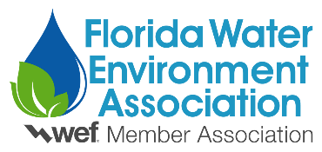
Judges Scoring Sheet
2024 Students and Young Professionals Poster Competition

Judge:

Poster Number:

Category | Description | Max Points | Score
Appearance and Structure (35 pts) | Adherence to poster requirements | 10
 | - Organized such that research data, plans, or case studies stand for themselves
 | - Title banner contains title, author(s) and school/employer
 | - Able to clearly see material
 | - Maximum of 4' x 8' in size
 | Content organization and logical flow of poster presentation | 20
 | - Clear concise objective section
 | - Followed by an experimental section (if applicable)
 | - Results are the main focus of poster
 | - Conclusions
 | - Flows top to bottom and left to right
 | Abstract/Participation form submitted on time | 5
Content (55 pts) | Technical content (clear objective, easy to understand, graphics, were appropriate, level of detail) | 30
 | Easy to understand without presenter being present | 10
 | Relevance to industry | 15
Discussion (10 pts) | Did the poster evoke spontaneous questions? Was the presenter able to answer questions? | 10
Total |  | 100

