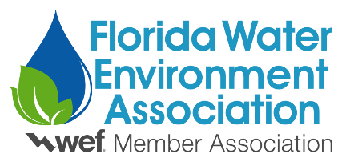
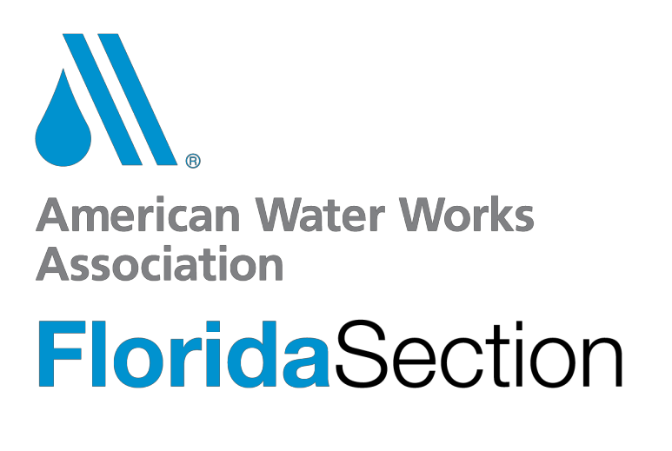

2023 STUDENTS AND YOUNG PROFESSIONALS POSTER COMPETITION
PARTICIPATION FORM

Important Dates:
May 5, 2023 | Submit this form to Alex Garlaschi (alex.garlaschi@kimley-horn.com)
May 12, 2023 | Deadline for students to submit resumes. (Resumes are not required for participation)
June 2, 2023 | Presentation at Florida Water Resources Conference

Participant Information (Award checks will be made out to and mailed to the person/address listed below. Please notify Poster Chair of any changes.)

Name: Phone: Email: Address:

City:
State:
Zip:

Poster Category (choose one): Student Young Professional Please read the statement below and check the box:
I have read the 2023 S&YP Poster Competition Guidelines and confirm that I meet the qualifications for either student or young professional.

Poster Title:

