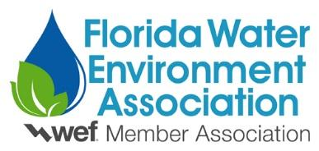
2022 STUDENT DESIGN COMPETITION
PARTICIPATION FORM

Form must be filled out electronically. Hand written forms will not be accepted.
University:
Team Name:
Presentation Title:

Team Members: (check box if presenting and/or attending FWRC – refer to guidelines)
Name: ____________________________________ Presenter Attending FWRC

Name: ____________________________________ Presenter Attending FWRC

Name: ____________________________________ Presenter Attending FWRC

Name: ____________________________________ Presenter Attending FWRC

Name: ____________________________________ Presenter Attending FWRC

Name: ____________________________________ Presenter Attending FWRC

Name: ____________________________________ Presenter Attending FWRC

Name: ____________________________________ Presenter Attending FWRC

Special Requirements: (describe any special equipment needs)
___________________________________________________________________________________
___________________________________________________________________________________

This Participation Form should submitted electronically to the Students & Young Professionals Committee Chair by April 10, 2022:

George Dick
Carollo Engineers
101 E. Kennedy Blvd. Suite 700
Tampa, Florida 33602
Work: 813-437-8908
Cell: 727-452-9725
Email: gdick@carollo.com

