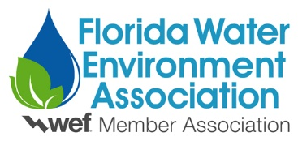
2021 FWEA Public Education Awards
The FWEA Public Education Awards recognize FWEA members for significant accomplishments in promoting awareness and understanding of water environment issues among the general public. These accomplishments include the development of and implementation of public education programs, educational resources, public outreach events, and/or campaigns.
The FWEA Public Education Awards are judged by a subcommittee of judges representing the Public Communications and Outreach Committee (PCOC).
Categories:
- Individual
- Organization- examples include education and/or outreach programs (do not have to be formally recognized), large scale efforts within an organization to promote public education over time (i.e. not a singular event), etc. Organizations that have participated in one time events should apply under the “Event and/or Campaigns” category.
- Events and/or Campaigns – examples include one time and/or short-term events like a festival or series of “open houses.” An example would be a municipality that plans and executes a successful event (i.e. an expo or festival) that is not associated with a formal education and/or outreach program. Campaigns are usually focused on a message and include multiple channels for getting the message out (i.e. a municipality distributes flyers and runs tv commercials to promote “The Unflushables” over a given period of time).
Criteria:
The criteria are the same for each category.
- Documented achievements of water environment public education programs and activities.
- A detailed narrative description of activities or efforts, including the objective and results.
- A short narrative describing the impacts of these activities or efforts on the public.
- Member of the Florida Water Environment Association.

Submit:
• FWEA Public Education Award Application
• Biography for the Individual Category nominee (if applicable)
• Specific reasons for nomination. See criteria above (three pages maximum).
• Copies of supporting documents in PDF form (limit is three pages).

All of the above documents must be uploaded as one PDF to the FWEA Awards page:
https://mms.fwea.org/members/form_edit.php?org_id=FWEA&fid=3225759

Nominations Accepted From:
FWEA members
FWEA chapters
FWEA committees

Nominations Deadline: February 19, 2021
For more information, please contact the Public Education Awards Chair or the PCOC Chair.

